WEB TECHNOLOGIES 1
Assignment #5: Advanced JavaScript and DOM Manipulation
KFC Bosses | KFC Kazakhstan Fan Project | Group SE-2510
Team: Zharkyn Akhmetov · Alnur Bakbergenov · Khantore Orynbassar
Deployed website URL: WEB-1 Assignment5

1. Objective
The objective was to extend the existing multi-page KFC-themed educational website with advanced JavaScript and DOM manipulation features. The assignment focused on improving user interaction through keyboard navigation, dynamic content, event handling, sound effects, animations, and a multi-step form. It also aimed to demonstrate the use of JavaScript objects, arrays, loops, and higher-order functions. The project is a student fan website, not an official KFC service.

2. Project Overview
The project includes seven pages: Main Menu, Food Menu, Special Offers, Our Team, Location & Schedule, Reviews & Feedback, and Gallery. The pages share JavaScript and CSS assets. All team members are listed in the footer. Each team member must be able to explain the implementation during the defense.
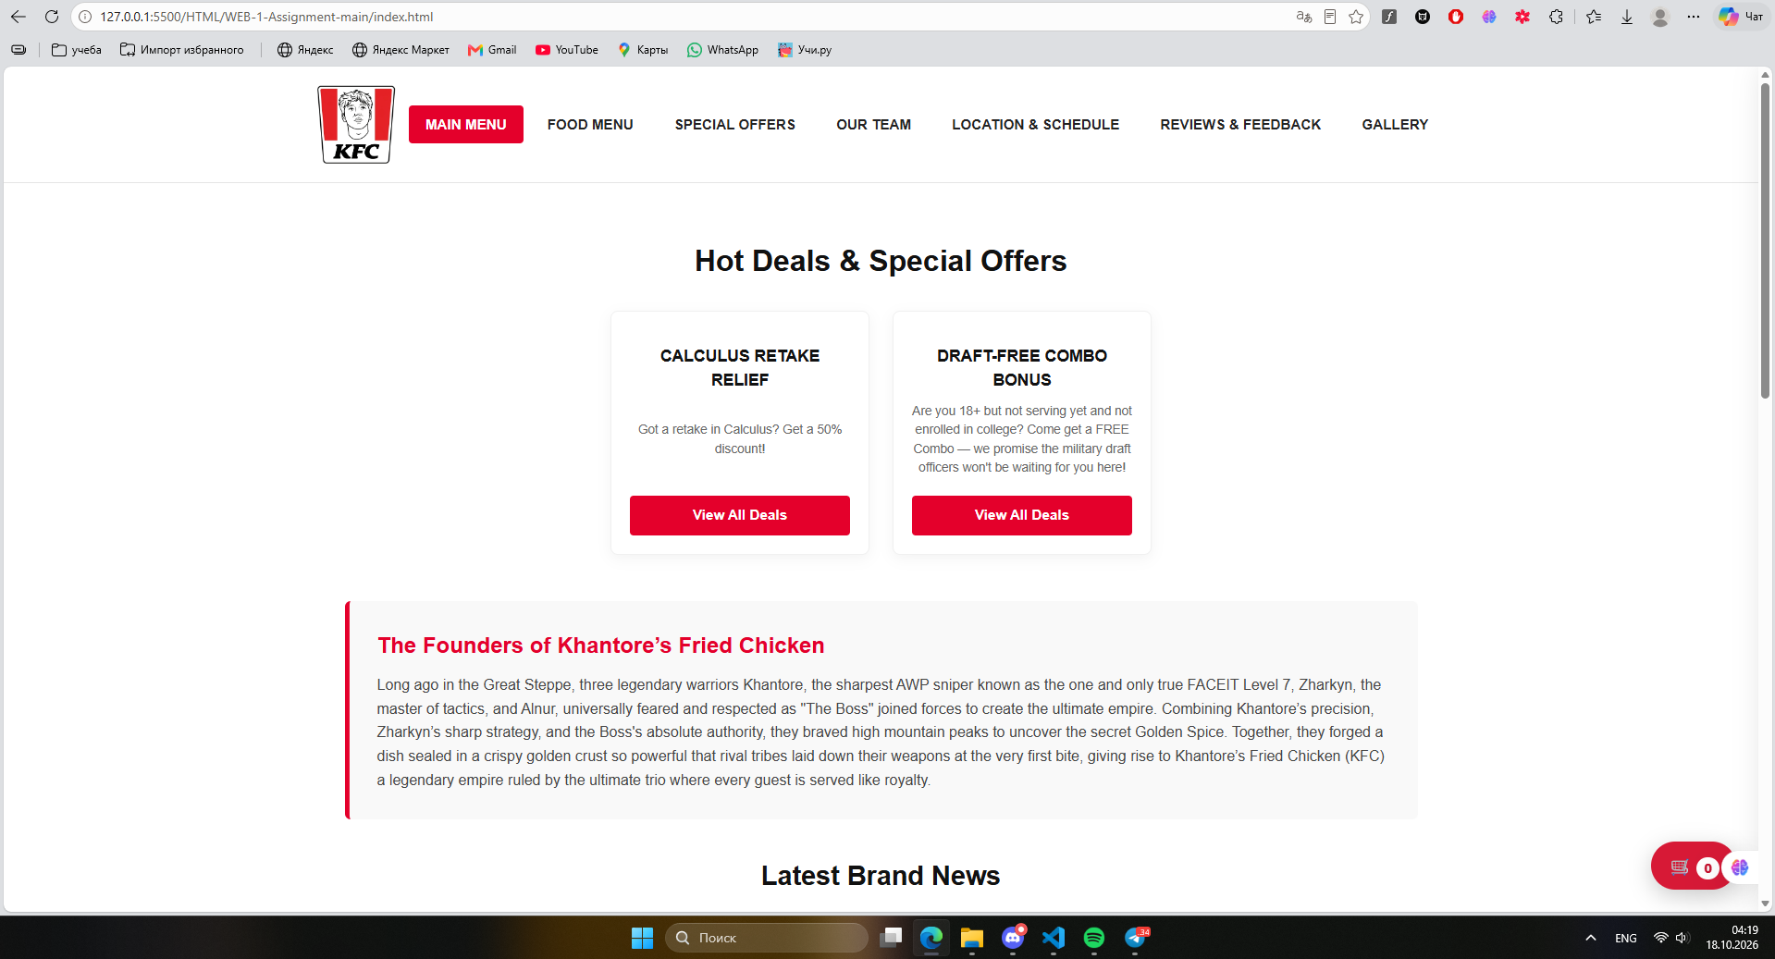
Figure 1. Main page showing the existing website design and navigation

3. 1. DOM Manipulation and Styling
JavaScript is used to select and modify HTML elements dynamically. The existing background color feature allows users to change the page background by clicking a button.
- Select the required HTML elements using DOM methods.
- Add an event listener to the background color button.
- Update the background color dynamically when the button is clicked.
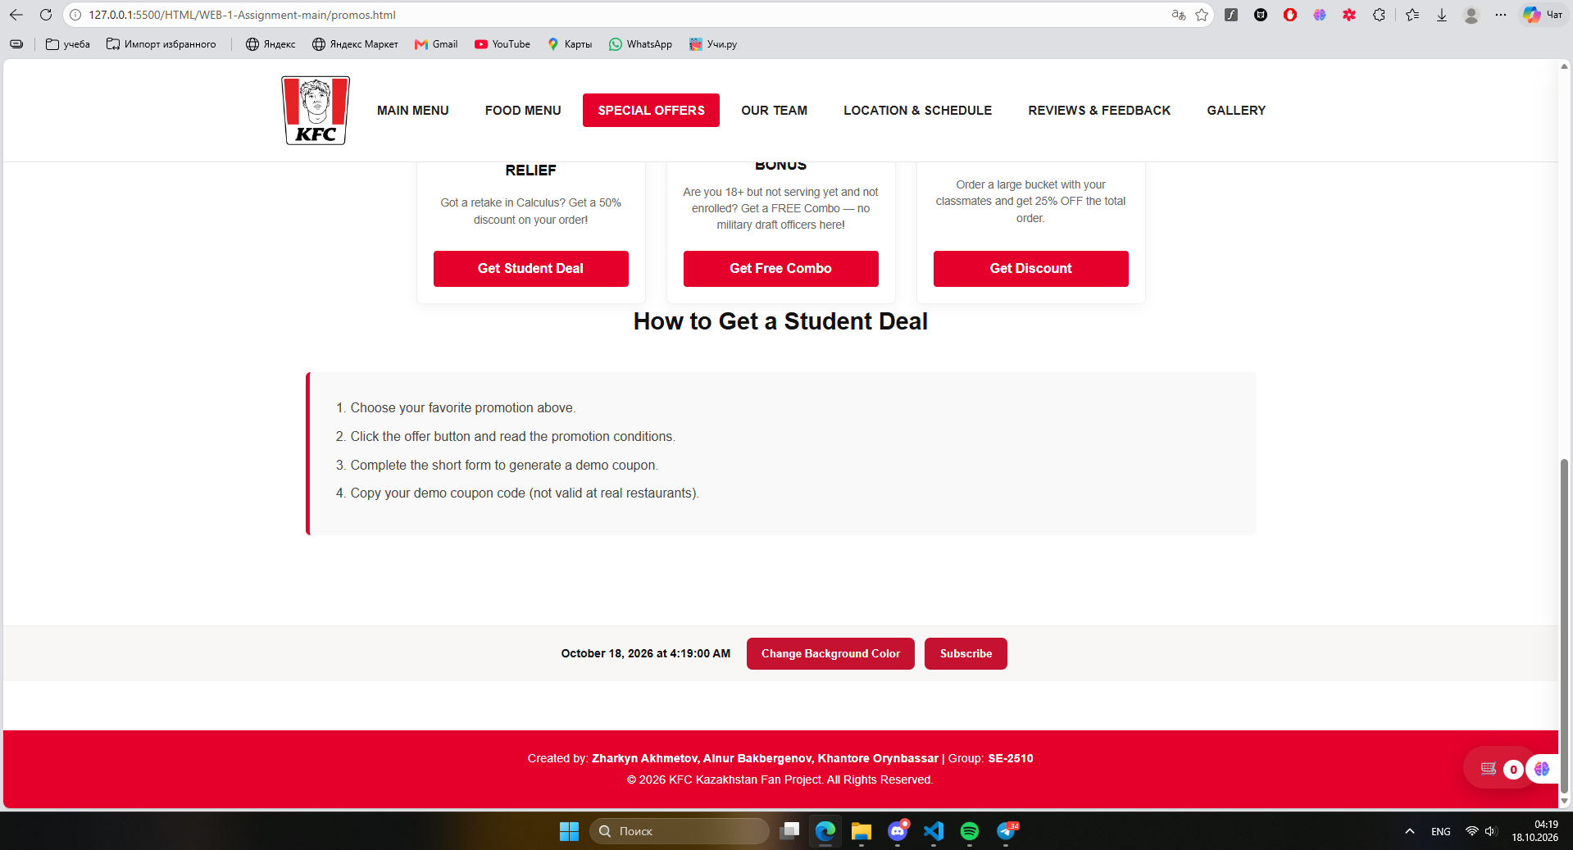
Figure 2. Page before changing the background color.
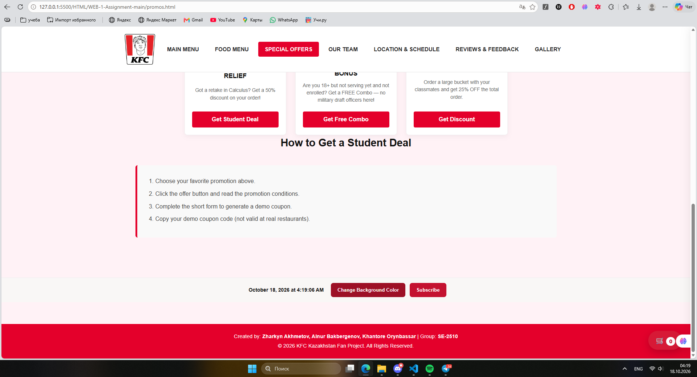
Figure 3. Page after changing the background color to light pink.
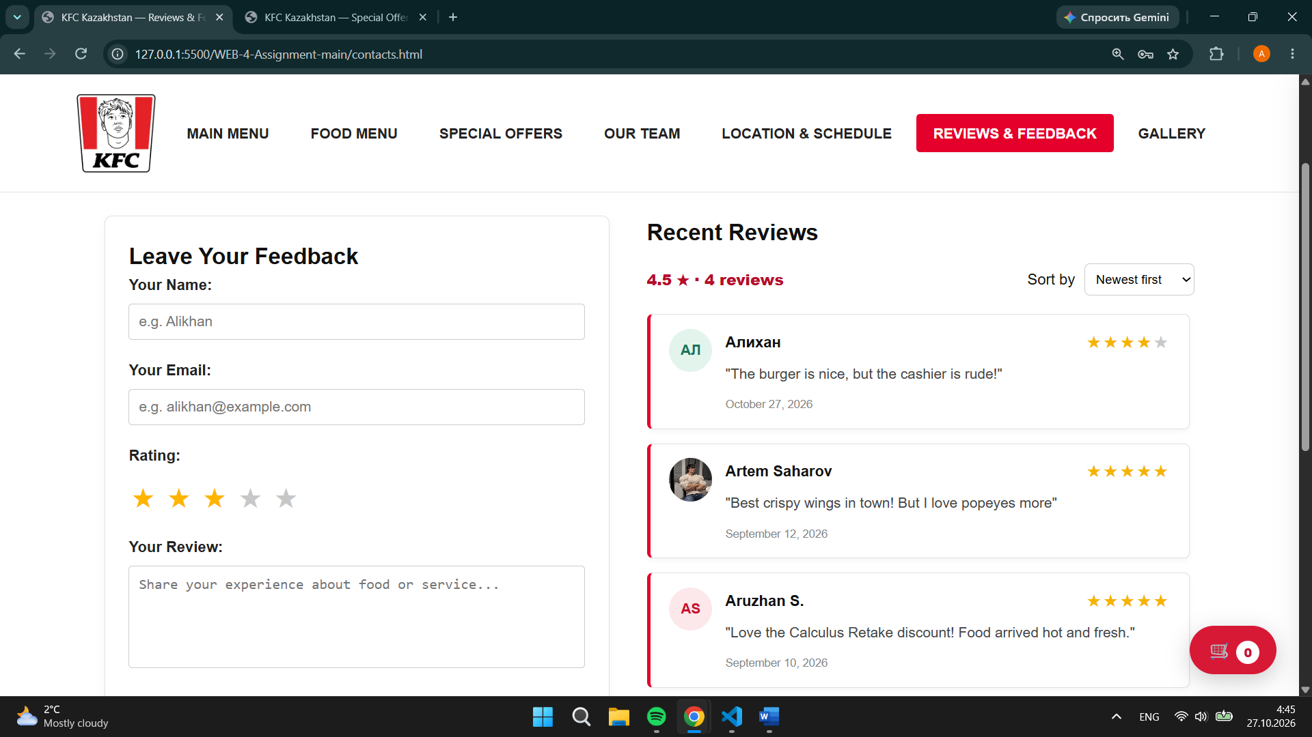
Figure 4. Using document.querySelectorAll to select rating stars

2. Event Handling
The image gallery allows users to select thumbnails and display the corresponding image in a larger view. JavaScript updates the image src attribute when a thumbnail is clicked.
- Select the main image and thumbnail elements.
- Add click event listeners to the thumbnails.
- Update the main image source based on the selected thumbnail.
- Test the gallery navigation and image display.
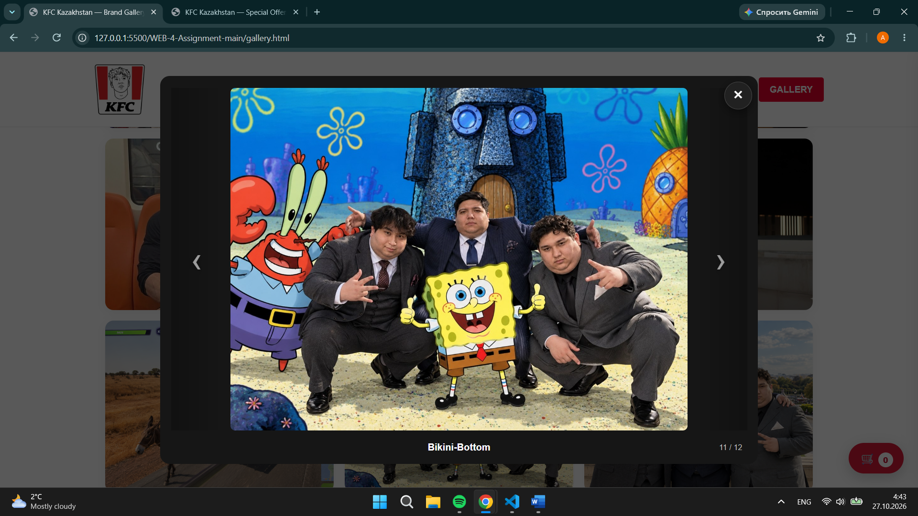
Figure 5. Gallery showing the selected image
.
3. JavaScript Advanced Concepts
Keyboard navigation was added to make the website easier to use without a mouse. JavaScript handles keyboard events when a navigation link is focused.
- Select the navigation menu and its links.
- Add a keydown event listener to detect keyboard input.
- Use the left and right arrow keys to move between links.
- Support the Home and End keys to move to the first and last links.
..\Videos\2026-10-27 04-56-16.mp4
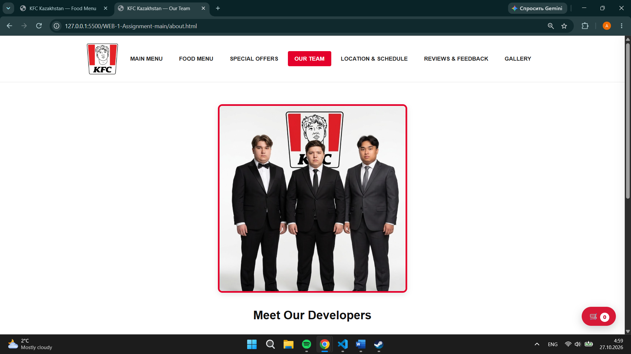
Figure 6. Website navigation with keyboard focu

4. Multi-Step Form and Callbacks
A multi-step form was added to the Special Offers page. Users can move between form steps and receive a confirmation message after completing the form.
- Create separate form steps with input fields and navigation buttons.
- Add event listeners to the Next and Back buttons.
- Use JavaScript functions to display the appropriate step based on user actions.
- Display a confirmation message after the form is completed.
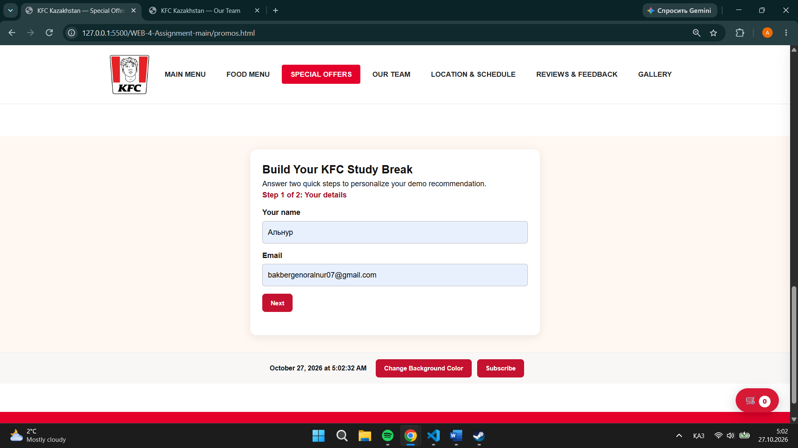
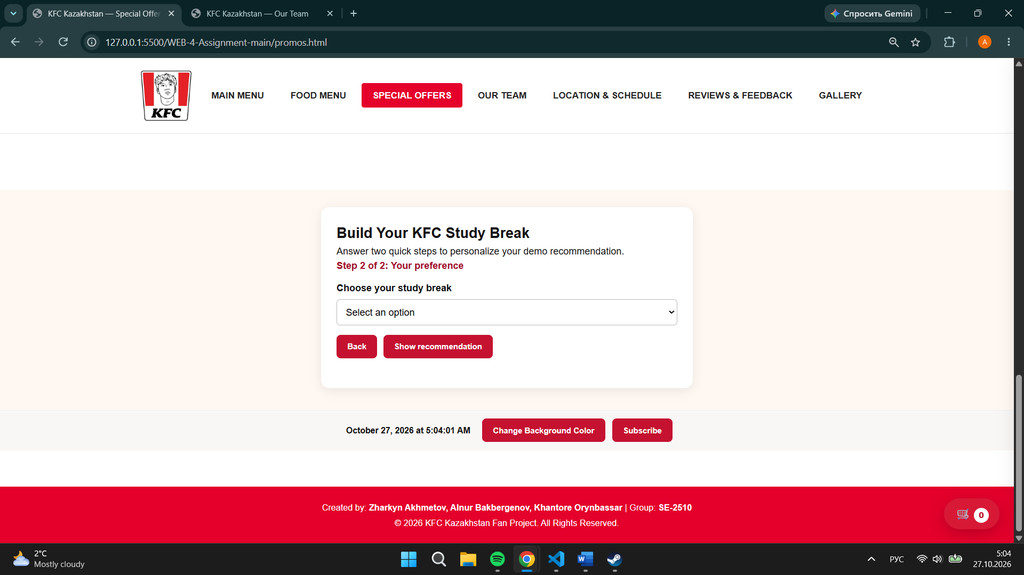
Figure 7-8. Multi-step form showing the final confirmation message.

5. Switch Statements
A greeting feature uses a switch statement to display a message based on the current time of day.
- Obtain the current hour using the JavaScript Date object.
- Use a switch statement to determine the appropriate greeting.
- Display the greeting dynamically on the webpage.
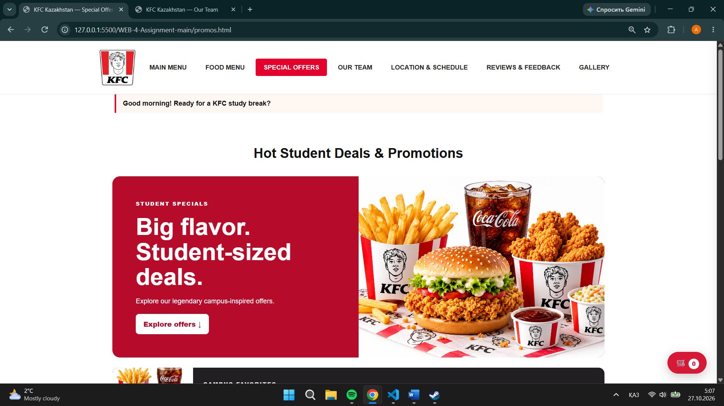
Figure 9. Greeting displayed on the webpage.

8. Sound Effects
Sound effects were added to selected interactive elements to provide audio feedback when users perform actions.
- Create a JavaScript function using the Web Audio API to generate a short sound.
- Connect the function to selected interactive elements.
- Test the sound effects by interacting with the webpage.
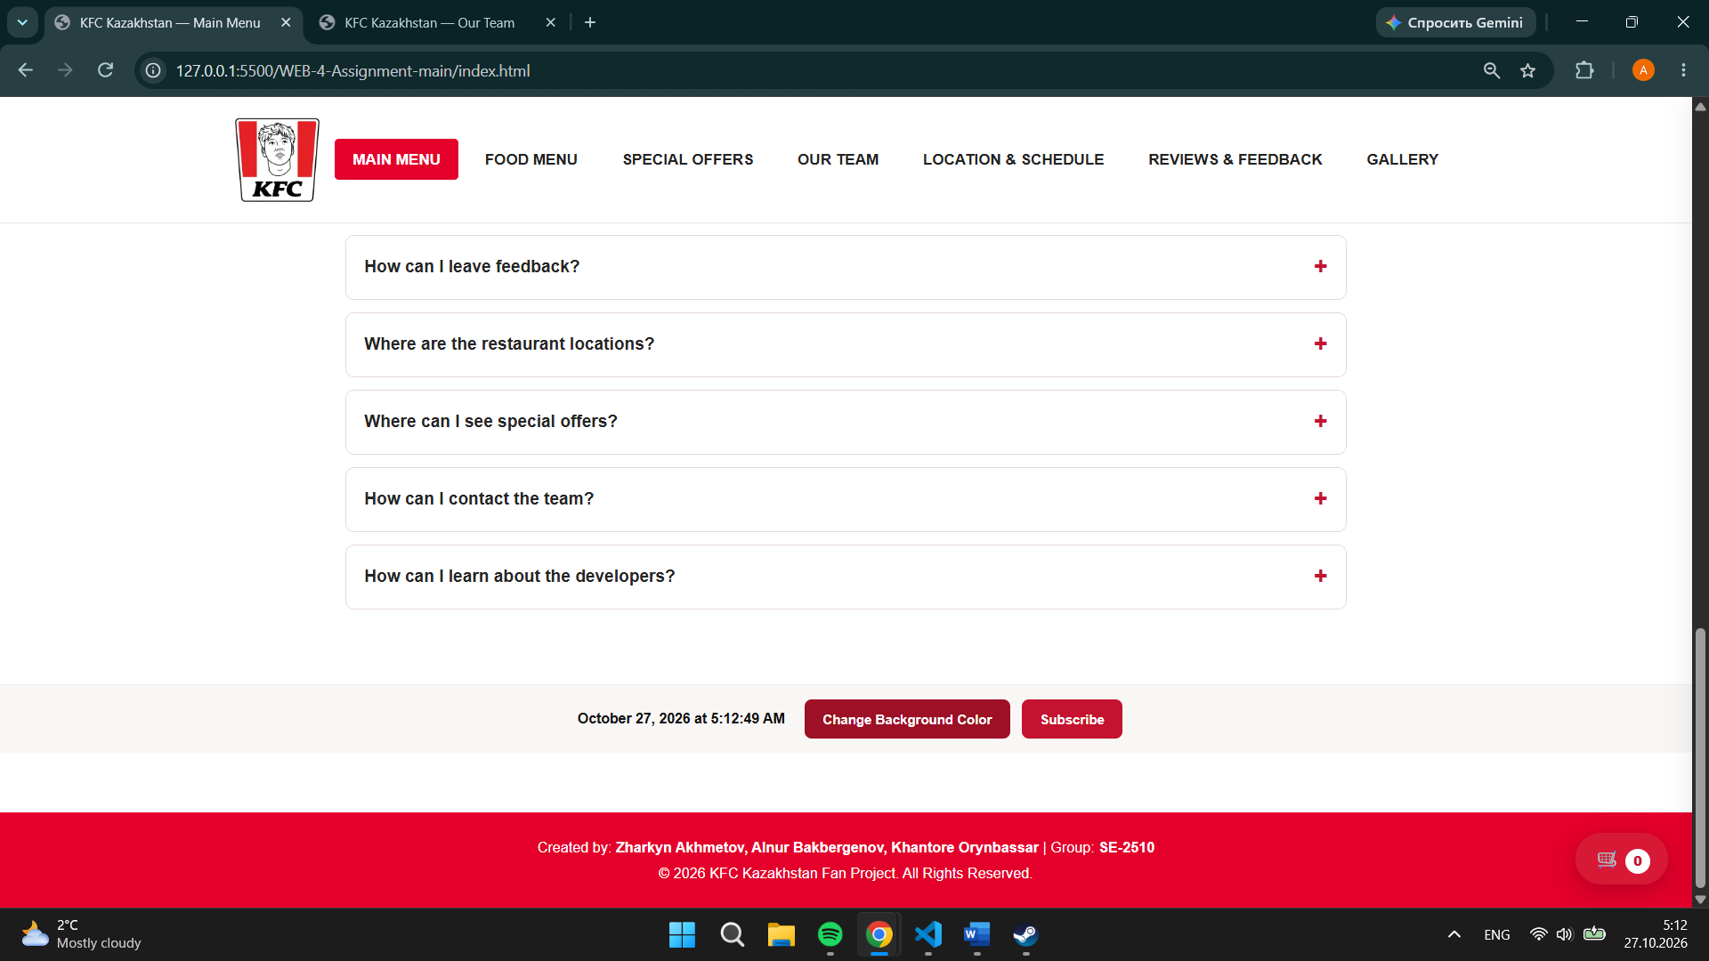
Figure 10. Webpage showing the button with a sound(Change Background Color)

9. Animations
Animations and transitions improve the visual appearance and interactivity of the website.
- Use CSS transitions and JavaScript to control visual effects.
- Trigger the relevant effects through user interaction or page scrolling.
- Test the animations to ensure that they work correctly.
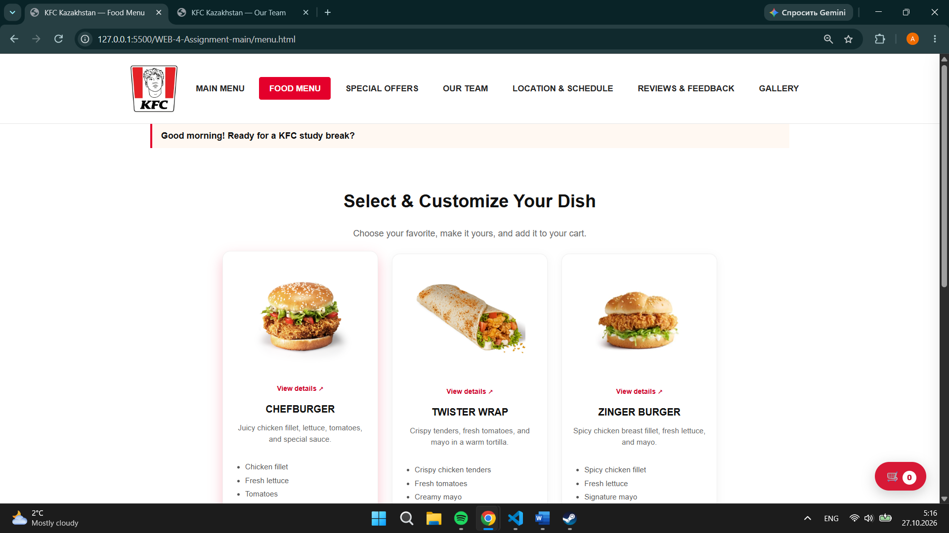
Figure 11. Webpage demonstrating the animation effect.

10. Code Organization and Testing
The project separates HTML structure, CSS styling, and JavaScript behavior into different files. The new assignment5.js file is connected to all seven HTML pages.
- Organize the code into separate HTML, CSS, and JavaScript files.
- Connect the new JavaScript file to each webpage.
- Test the new features and check that the existing website functionality continues to work.
- Review the webpages to ensure that the project runs without errors.

11. Deployment and Collaboration
The updated project must be pushed to the shared repository and published through GitHub Pages or Netlify. Replace the deployment URL placeholder on the first page with the public URL before submission. The report and complete project ZIP must both be submitted. Each member is responsible for understanding the components and demonstrating them during the practice lesson.

12. Conclusion
The assignment demonstrates how advanced JavaScript and DOM manipulation can improve an existing website. Keyboard navigation, a multi-step form, dynamic greetings, sound effects, and animations provide additional interactivity. The project also demonstrates the use of event listeners, callbacks, switch statements, arrays, objects, loops, and higher-order functions.

